Name of the faculty | SRINIVASA MURTHY MK |  | 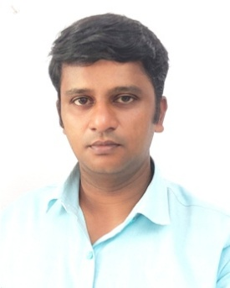
Designation | Assistant Professor
Department | Robotics & Artificial Intelligence
Date of Joining the institution | 24-02-2007
Qualification | UG:BE | PG:M.Tech | Ph. D: Persuing
Total Experience in Years | 18 years 7 months | Industry | Research
Total Experience in Years | 18 years 7 months | NIL | 4
Paper Published in Journals | National: NIL | International :7
Paper Presented in Conference/Symposium | National: NIL | International:01
Ph D. Guide, Field & University | Dr.Mruthyunjaya Swamy KB  Dr.Arun Kumar Shettigar | Machine Learning in Robotics | NITK, Surathkal
Ph D s/ Project Guided | No of Ph D’s Guided: NIL  No of Ph D’s Guiding: NIL |  | Projects at Masters Level: 05
Books Published/IPR/Patents | NIL
Professional Membership | IE, MISTE
Consultancy Work Taken  (Project,Company,Amount) | NIL
Awards Received | NIL
Members of BOE,BoS or Any other | NIL
Grants/Funding Received  (Project,acency,amount,year) | NIL
Industry Interactions, Professional Institutions, MoUs | NIL

