Name of the faculty | Sushma U K |  | Attach Photo here  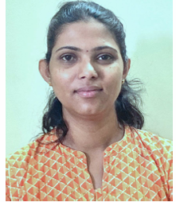
Designation | Assistant Professor
Department | RAI
Date of Joining the institution | 07-10-2024
Qualification | UG:BE | PG: MTech (DEC) | Ph.D: Pursuing (Medical Image Processing)
Total Experience in Years | 15 | Industry | Research
Paper Published in Journals | National | International
Paper Presented in Conference/Symposium | National | International
Ph D. Guide, Field & University
Ph D s/ Project Guided | No of Ph D’s Guided:  No of Ph D’s Guiding |  | Projects at Masters Level:
Books Published/IPR/Patents
Professional Membership | IE,IAENG,IEEE
Consultancy Work Taken
(Project,Company,Amount)
Awards Received
Members of BOE,BoS or Any other
Grants/Funding Received
(Project,acency,amount,year)
Industry Interactions, Professional Institutions, MoUs

